**APPLICATION PROGRAMMING**

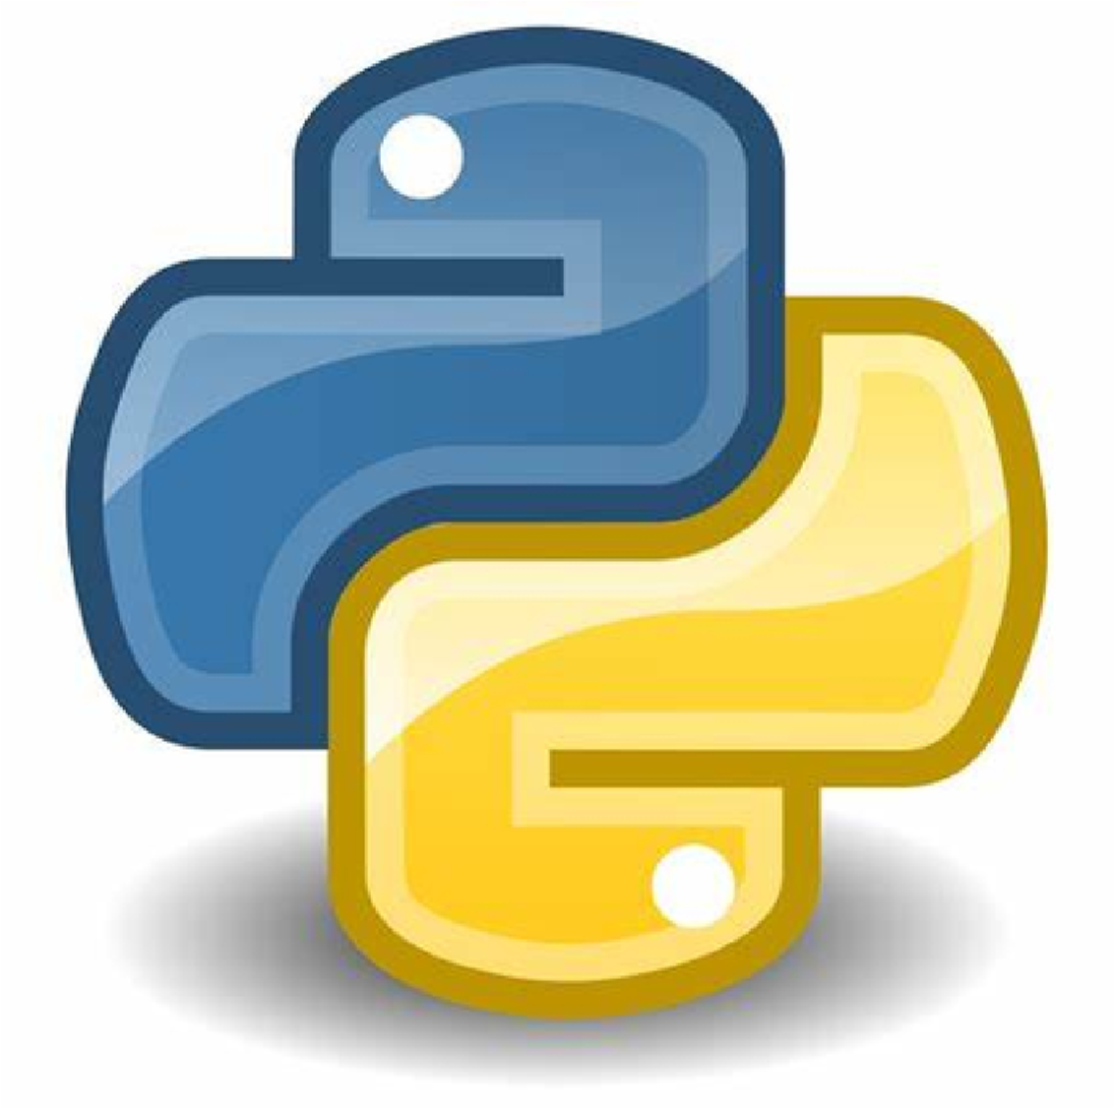

**PYTHON**

**DATA ANALYSIS OF**

721_Sakshi Y. Dube

706_Shrusti U. Bankar

713_Sapna Dahikamble

726_Nikita Hakande

**M**

**A**

**N**

**U**

**F**

**A**

**C**

**T**

**U**

**R**

**I**

**N**

**G**

**E**

**N**

**T**

**E**

**R**

**P**

**R**

**I**

**S**

**E**

**U**

**S**

**I**

**N**

**G**

**P**

**Y**

**T**

**H**

**O**

**N namnamanamma**



**1**

**I**

**N**

**T**

**R**

**O**

**D**

**U**

**C**

**T**

**I**

**O**

**N**



**O**

**V**

**E**

**R**

**V**

**I**

**E**

**W**

I

n

t

h

i

s

p

r

o

j

e

c

t

w

e

a

r

e

d

e

a

l

i

n

g

w

i

t

h

h

o

w

p

y

t

h

o

n

i

s

u

s

e

d

i

n

f

i

n

d

i

n

g

M

e

d

i

a

n

,

M

o

d

e

a

n

d

S

t

a

t

i

s

t

i

c

D

a

t

a

w

h

i

c

h

i

s

u

s

e

d

b

y

m

a

n

u

f

a

c

t

u

r

i

n

g

c

o

m

p

a

n

y

t

o

a

n

a

l

y

s

e

p

r

o

g

r

e

s

s

**REAL TIME USES**

1. To check progress of enterprise
2. To analyse trends

**LIBRARIES USED**

**a) PANDAS**:-

Pandas is a software library used in python for data manupulation and analysis. It offers data

structure and operation in numerical table.

**b)MATPLOTLIB**:-

Its is a cross-platform, data visualization and graphical plotting in python and also numerical extension of

numpy

